Object Class in Java
Object class (in java.lang) is the root of the Java class hierarchy. Every class in Java either directly or indirectly extends Object. It provides essential methods like toString(), equals(), hashCode(), clone() and several others that support object comparison, hashing, debugging, cloning and synchronization.

Why Object Class?
- Acts as the root of all Java classes
- Defines essential methods shared by all objects
- Provides default behavior for printing, comparing and cloning objects
- Supports thread communication (wait(), notify(), notifyAll())
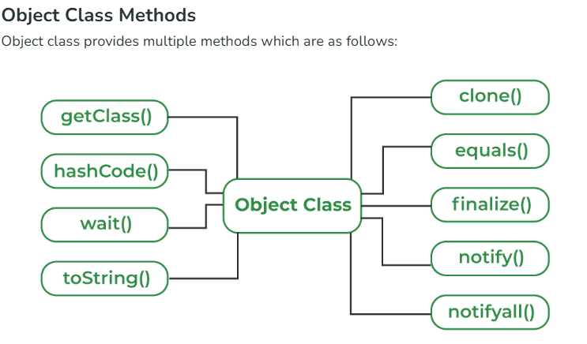

1. toString() Method
toString() provides a String representation of an object and is used to convert an object to a String.

2. hashCode() Method
hashCode() method returns the hash value of an object (not its memory address). Used heavily in hash-based collections like HashMap, HashSet, etc.

3. equals(Object obj) Method
equals() method compares the given object with the current object. It is recommended to override this method to define custom equality conditions.

class Book{

String title;

Book(String title) {
this.title = title;
}

@Override
public boolean equals(Object obj){

Book b = (Book) obj;
return this.title.equals(b.title);
}

public static void main(String[] args) {
Book b1 = new Book("Java");
Book b2 = new Book("Java");

System.out.println(b1.equals(b2)); // true
}
}

4. getClass() method
getClass() method returns the class object of "this" object and is used to get the actual runtime class of the object.

public class Student{

public static void main(String[] args)
{
Object o = new String("GetClassMethodDemo");
Class c = o.getClass();
System.out.println("Class of Object o is: "+ c.getName());
}
}

5. finalize() method
finalize() method is invoked by the Garbage Collector just before an object is destroyed. It runs when the object has no remaining references. You can override finalize() to release system resources and perform cleanup, but its use is discouraged in modern Java.

public class FinalizeDemo {
public static void main(String[] args) {

FinalizeDemo t = new FinalizeDemo();
System.out.println(t.hashCode());

t = null;

// calling garbage collector
System.gc();

System.out.println("end");
}

@Override protected void finalize()
{
System.out.println("finalize method called");
}
}

6. clone() method
clone() method creates and returns a new object that is a copy of the current object.
class CloneObj implements Cloneable{

int id = 1;
String name = "Vishnu";

@Override
public Object clone() throws CloneNotSupportedException{

return super.clone(); // shallow copy
}

public static void main(String[] args) throws Exception{

CloneObj s1 = new CloneObj();
CloneObj s2 = (CloneObj) s1.clone();

System.out.println(s1.name); // Vishnu
System.out.println(s2.name); // Vishnu
}
}

